41.6: a) As in Example 41.3, the probability is

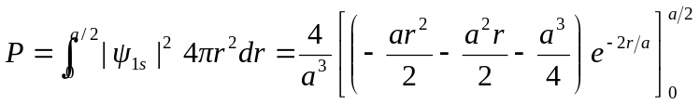
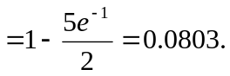
b) The difference in the probabilities is

